**Assignment -3**

|  |  |
| --- | --- |
| Assignment Date | 22 September 2022 |
| Student Name | Gopinath S |
| Student Roll Number | 111519205008 |
| Maximum Marks | 2 Marks |

**Question 1:**

Create a bucket in IBM object Storage.

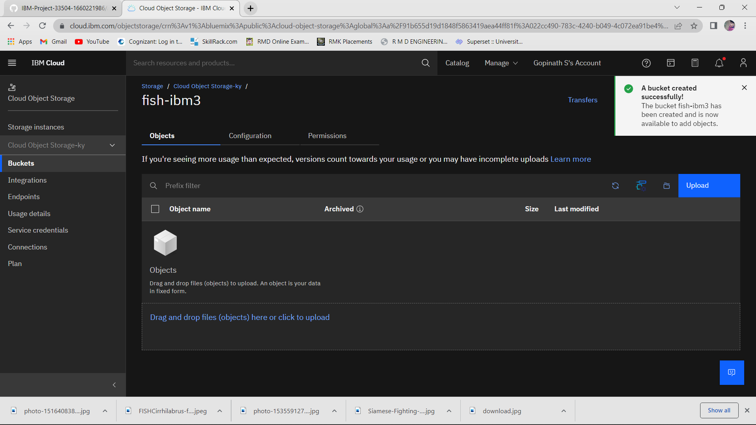

**Question 2:**

Upload any 5 images to IBM object storage and make it public. Write HTML code to display all the 5 images.

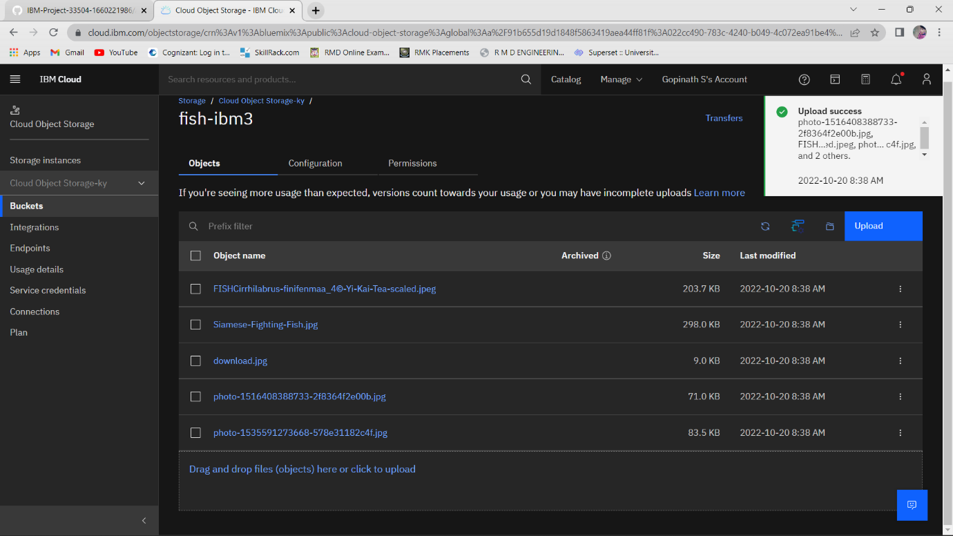

**HTML code for displaying images in cloud :-**

<!DOCTYPE html>

<html lang="en">

<head>

    <meta charset="UTF-8">

    <meta http-equiv="X-UA-Compatible" content="IE=edge">

    <meta name="viewport" content="width=device-width, initial-scale=1.0">

    <title>Document</title>

</head>

<style>

    body{

        text-align: center;

        background-color: blue;

    }

    h2{

        color: red;

        font-size: 50px;

    }

    h1{

        color: white;

        text-align: center;

        font-size: 75px;

    }

    img{

        height: 230px;

        width: 430px;

    }

</style>

<body>

    <h1>FISH</h1>

    <h2>pic1</h2>

<img src="https://fish-ibm3.s3.jp-tok.cloud-object-storage.appdomain.cloud/FISHCirrhilabrus-finifenmaa_4%C2%A9-Yi-Kai-Tea-scaled.jpeg" alt="pic1">

<h2>pic2</h2>

<img src="https://fish-ibm3.s3.jp-tok.cloud-object-storage.appdomain.cloud/Siamese-Fighting-Fish.jpg" alt="pic2">

<h2>pic3</h2>

<img src="https://fish-ibm3.s3.jp-tok.cloud-object-storage.appdomain.cloud/download.jpg" alt="pic3">

<h2>pic4</h2>

<img src="https://fish-ibm3.s3.jp-tok.cloud-object-storage.appdomain.cloud/photo-1516408388733-2f8364f2e00b.jpg" alt="pic4">

<h2>pic5</h2>

<img src="https://fish-ibm3.s3.jp-tok.cloud-object-storage.appdomain.cloud/photo-1535591273668-578e31182c4f.jpg" alt="pic5">

</body>

</html>

**HTML Output for displaying images from IBM cloud storage: -**

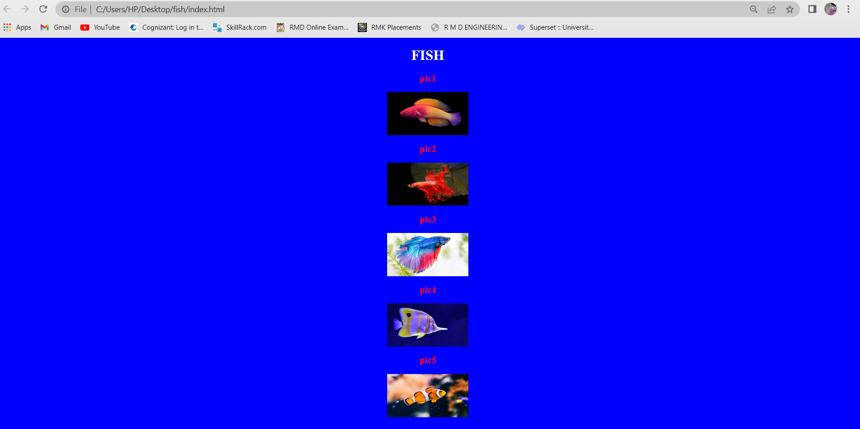

**Question 3:**

Upload a CSS page to the object storage and use the same page in your HTML code. HTML code with CSS file present in IBM cloud storage.

**Style.css code:**

body{

    background-color: black;

}

h1{

    text-align: center;

    color: orangered;

}

p{

    color: white;

    text-align: center;

}

`

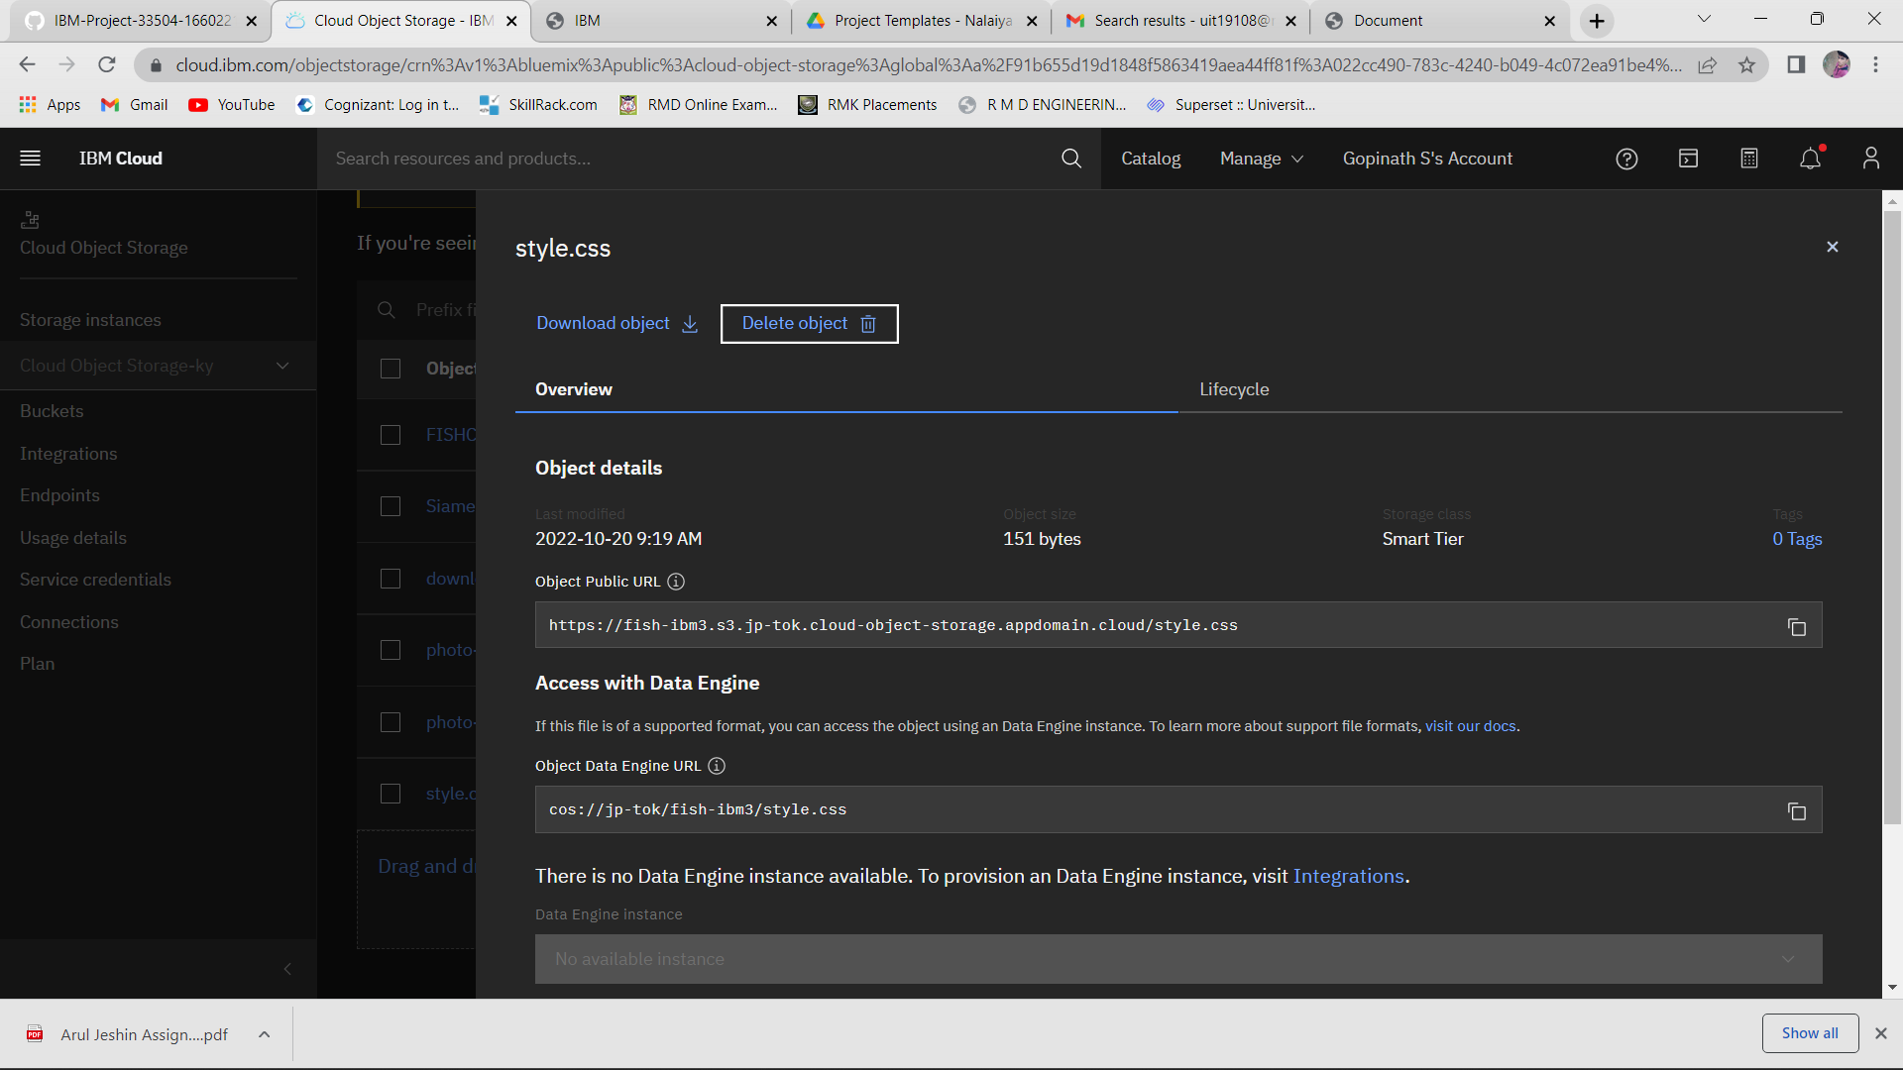

**HTML code:**

<!DOCTYPE html>

<html lang="en">

<head>

    <meta charset="UTF-8">

    <meta http-equiv="X-UA-Compatible" content="IE=edge">

    <meta name="viewport" content="width=device-width, initial-scale=1.0">

    <link rel="stylesheet" href="https://fish-ibm3.s3.jp-tok.cloud-object-storage.appdomain.cloud/style.css">

    <title>Simple</title>

</head>

<body>

    <h1>NARUTO</h1>

    <p>

        Fishes are typically divided into three groups: superclass Agnatha (jawless fishes), class Chondrichthyes (cartilaginous fishes), and superclass Osteichthyes (bony fishes).

    </body>

</html>

**HTML code output:**

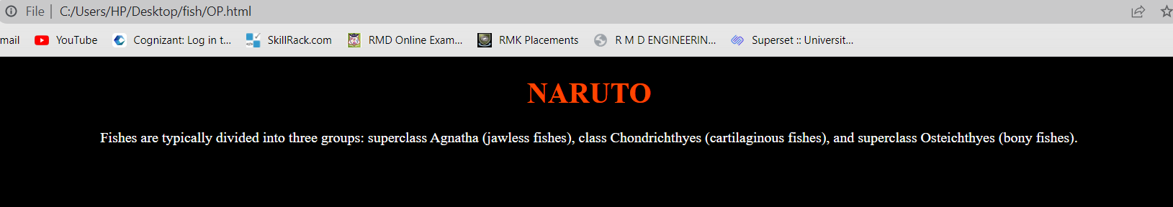

**Question 4:**

Design a chatbot using IBM Watson assistant for hospitals. Ex: User comes with a query to know the branches for that hospital in your city. Submit the web URL of that chat bot as an assignment.

**URL for the Chat Bot :**

https://web-chat.global.assistant.watson.appdomain.cloud/preview.html?backgroundImageURL=https%3A%2F%2Fau-syd.assistant.watson.cloud.ibm.com%2Fpublic%2Fimages%2Fupx-6600f2b6-2cdd-4deb-a67c-1ecbeda8ee7b%3A%3A17d03ac1-bab2-4559-9794-49b4f88515ca&integrationID=597f5ddd-f103-4a8d-8fd4-7d1c41d3fc5e&region=au-syd&serviceInstanceID=6600f2b6-2cdd-4deb-a67c-1ecbeda8ee7b

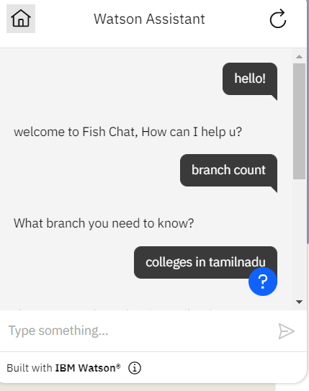

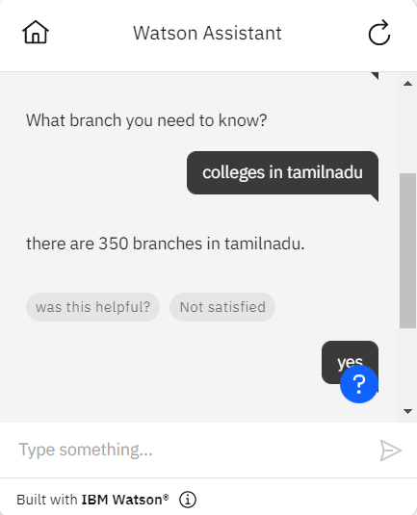

**Question 5:**

Create a Watson assistant service with 10 steps and use 3 conditions in it. Load that script in the HTML page.

**HTML CODE:**

<!DOCTYPE html>

<html lang="en">

<head>

<meta charset="UTF-8">

<meta http-equiv="X-UA-Compatible" content="IE=edge">

<meta name="viewport" content="width=device-width, initial-scale=1.0">

<title>Chat bot</title>

<style>

h1{

text-align: center;

color: #ffffff;

}

body{

background-color: #000000;

}

input[type="text"],input[type="password"]{

height: 42px;

width: 400px;

font-family: cursive;

border-radius: 100px;

background-color:rgb(15, 237, 174) ;

}

input[type="submit"]{

height: 42px;

width: 100px;

color: #000;

background-color: rgb(236, 232, 14);

font-size: medium ;

margin-top: 20px;

border-radius: 50px;

}

p{

color: #ffffff;

font-size: 28px;

}

form{

text-align: center;

}

small{

color: #ffffff;

}

img{

fill: auto;

}

</style>

</head>

<body>

<h1>Jeshin Welcomes you!!!</h1>

<h1>login to your account</h1>

<form>

<p>Enter-Username </p>

<input type="text" >

<br><br>

<p>Enter-Password </p>

<input type="password">

<br><br>

<input type="submit" value="login" >

<br><br>

<small>Click here to browse more <a href="https://www.youtube.com/watch?v=E40UEoa19As"> info</a></small>

</form>

<script>

  window.watsonAssistantChatOptions = {

    integrationID: "3c7e7559-008d-415e-9bee-db9d1950d6ea", // The ID of this integration.

    region: "jp-tok", // The region your integration is hosted in.

    serviceInstanceID: "a87d6922-53f6-49ac-9e54-24769839b6ba", // The ID of your service instance.

    onLoad: function(instance) { instance.render(); }

  };

  setTimeout(function(){

    const t=document.createElement('script');

    t.src="https://web-chat.global.assistant.watson.appdomain.cloud/versions/" + (window.watsonAssistantChatOptions.clientVersion || 'latest') + "/WatsonAssistantChatEntry.js";

    document.head.appendChild(t);

  });

</script>

</body>

</html>

**App.py code:**

from flask import Flask, render_template

app = Flask(__name__)

@app.route("/")

def home():

    return render_template("index2.html")

@app.route("/salvador")

def salvador():

    return "Hello, Salvador"

if __name__ == "__main__":

    app.run(debug=True)

**HTML CODE OUTPUT:**

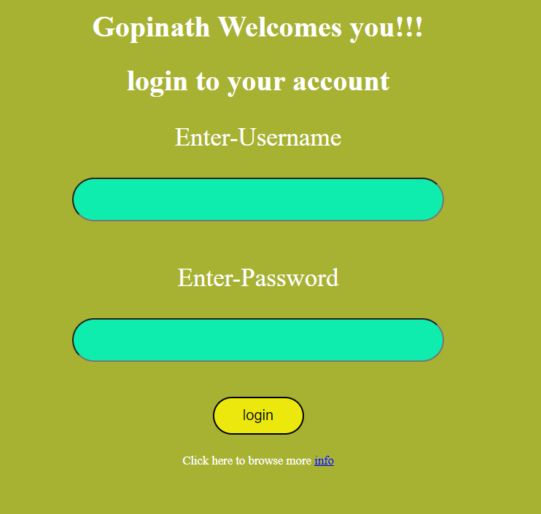

**ASSISTANT OUTPUT:**



